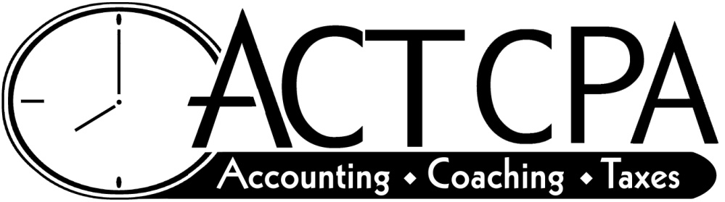
50 Oliver Street, Suite 215; N. Easton, MA 02356 Tel: 508-230-8756

Collection Policy
as of 1/10/22

Annual financial planning package, tax, accounting or bookkeeping fees are due when invoiced in full. As a courtesy, we will allow you to pay same as cash on one of the following payment methods.

- You can pay up to 10-month bill cycle without auto debit; however, payments must be made by the 15th of each month or you will be assessed a $25.00 late payment fee and 18% APR interest on your unpaid balance.

- You can pay on a 12-month bill cycle; however, you must fill out an e-pay form for us to debit your monies monthly from your checking account.

After missing two monthly payments on an agreed upon plan per your invoice, we retain the right to do the following:

- Place a hold on all accounting and tax work.
- Charge monthly late payment fees if monthly payment isn’t started again.
- Charge 18% interest on the unpaid balance.

Any changes to scheduled electronic payments (E-pays) need to be made as follows:

- Please notify us via a phone call or email TWO business days before the payment is to process.

- If you have given us TWO business days to make the change, we will refund any bounce fees that are incurred. Otherwise, you are responsible for all bounce fees incurred by my bank and your own.

Sincerely,

Deborah R. Bowman, CPA

